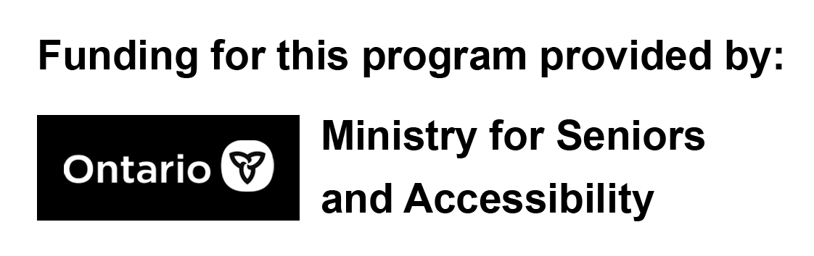

Part 2: Digital Literacy Workshop

Session Outline:

- Introduction
- Terminology
- Browsers
- Functions
- Accessories
- Myth Busters
- Q&A
- Feedback
- Resources

Section 1 – Introduction

Welcome everyone.
Go over microphones and how the mute and video camera button work.
I’d like to start off by saying that you should not fear using your devices, be bold, explore the features of your devices, and don’t be afraid to ask lots of questions to your network of family and friends who may know how to do something you don’t. Why not learn from them too?
This topic is about understanding technology. A little bit of what will be presented will be about computer and device terminology, basic use of features and functions and correct use of accessories and devices. This could be something you already know, it could be something new for you, or it may even just be a good refresher.

Section 2 – Terminology

- Computer: is an electronic device that handles information or data. It as the capability to store, transfer, and process data. You may already know that you can use a computer-like-device to send emails, play games, search for things and type documents.
- Mouse: A small device that is used with a single-hand to control the position of the cursor on the computer screen. Moving the mouse will move the cursor on your screen.
- Trackpad: A small touch sensitive area on a computer that allows you to control the cursor on the computer screen. Sliding your fingers on a trackpad will move the cursor on your screen.
- Touchscreen: A type of screen that replaces the need to have a cursor and mouse; allowing you to interact with a device by touching areas on the screen.
- Applications “Apps”: An application also known as an app, a program downloaded by a user to a mobile device. App’s perform specific tasks.
  - Ask participant at random to name an application that they are familiar with.
- Streaming: transmitting or receiving data over an internet enabled device, especially video and audio material. You are streaming when you are using applications such as YouTube, Spotify,
- Browser: an application used to quite literally browse/look through pages of information stored online.
- Back arrow (back button): often found at the top left corner of most browsers. When you click on the back arrow it takes you backwards, in order, through the webpages you had just visited.
  - Quick tip! If you are filling out information and submitting it online, choosing the back arrow in your browser may delete everything you’ve entered, especially if you have not saved that information.
- Reload / Refresh: This button is used when a page has not loaded entirely. This can occur at random, and for a number of reasons. If some or all of your page appears to be missing, you may choose to reload/refresh to make it work again.
- Home: It is possible to set the page that loads every time from your browser to a specific page. Choosing the home button will load/open up that page.
- Magnifying glass: Represents the search feature on a device. Clicking on or touching the magnifying glass will allow you to type keywords to search the web.
- Minimize: A small horizontal line on a browser that let’s to ‘hide’ your browser so you can multi-task. On a mobile device, simply returning to the home screen often minimizes your browser / app, making you think you’ve closed it, when really it is just temporarily hidden/suspended.
- Maximize: Used to make your browser full screen. On a mobile device browsers are often already full screen.
  - Quick tip! Sometimes you’ll see a different icon that will make what your viewing full screen. It will look like arrows facing away from each other towards the edge of the screen.
- Close: Often represented by an “X” in the corner, depending on a device, and depending on which application you are using. Clicking on or tapping on an “X” will inevitably close whatever window it is attached to.
  - Quick tip! If the “X” is in the furthermost corner on your screen, and you choose “X”, you likely will close that entire program.
- New Tab / Tab: opens a new tab. A tab is similar to the label you put on a folder in a filing cabinet. On a web browser, using the “+” symbol allows you to have multiple web pages open.
  - Quick tip! Generally, you can only view a single tab at any given time.
- Address box (Address bar): A narrow rectangular box where you can type in a web address. Typing into this box and hitting enter will take you to a website.
- Web Address (URL): Uniform Resource Locator. A designated address to a website managed by a person, business or organization. Here we will explain to participants the meaning of specific web address extensions.

.org | It was originally designed to represent not-for-profit organizations and still does for many, even today. It’s popular for many non-governmental organizations, politicians and political parties and other online communities.  Example: www.rexdalwomen.org
.ca | The ca lets you know you are likely on a Canadian website. This is good to know if you are shopping online and looking to practice safe online practices. It is similar to .com with the exception that it geographically specific to the country, Canada.  Example: www.canada.ca
.com | The com stands for commercial. Websites with this extension are generally intended for businesses meant for-profit. Many websites now use this extension for its familiarity.
.gc.ca | This domain/extension is privately owned by the Government of Canada.  Example: www.weather.gc.ca
.net | A popular generic extension for websites that can be used by just about anybody.
.co.uk | An example of an international or country specific URL. This example is for the United Kingdom

Section 3 – Browsers

Here we explore the most common browsers individuals use, to browse the web. Using the icons on the presentation slide to describe the icons for those who have called in to the presentation, and as visual cues for those who can see them. The purpose of this section is to familiarize participants with what they are likely already using, but do not fully understand.

Section 4 – Functions

- Download: The process of receiving a file over the internet to your device. It can also refer to the transfer of information from one computer system to another.
- Upload: To transfer something like files or data, from one digital device to the memory of another device.
- Share: This is used to share things. You can share web pages, photos, online shopping products etc.
- Icons: Icons are visual representations for applications. Most commonly, starting an application is done by clicking on or touching an icon.
- Link: A shortened variation of hyperlink. It is usually a word or button that, if clicked, will take you the website it related to.
- Scrolling: The act of moving displayed text or graphics up and down on a computer-like-device to view all parts.
- Faded Text: When you faded text, it usually means you will be able to write over it, without having to delete it. The faded text indicates what you need to enter into that field.
- Sign in: An action used to login or access a secured portion of a website or on a device. Also known as log on.
  - Example: You may have a password on your computer and tablet, requiring you to sign in. In order to access your email or online banking, you will need to sign in again.
- Airplane: Also known as Airplane Mode. Enabling this feature will completely disconnect you from the internet any mobile carrier access. This means you will not be able to make calls or browse the web or check your emails. This feature is most commonly used when travelling to avoid the need to turn off your phone.
- Wi-Fi: It is described as bunch of curved lines that get longer and longer, representing the way that radio signals work. When successfully connected to your wireless home internet this symbol will typically glow in affirmation.
- Bluetooth: This symbol kind of looks like a “B”. Bluetooth is a wireless signal that can be used to transfer data, connect to wireless headphones, mouse and keyboard. It cannot work at the same distance Wi-Fi works at.
- Do Not Disturb: Described as a crescent moon. Exactly what it sounds like. When this feature is enabled your device will generally not receive messages for a select period of time (i.e. 9:00 PM to 6:00 AM)
- Brightness: Look for the graphic of sunshine or the sun. No matter how your device works, interacting with this feature can help you control the brightness of your screen.
- Volume: It looks like a picture of the inside of a speaker followed by sound waves.
- Camera: Looks like a camera and can be used to record video and take pictures.
- Notifications: On your application icon sometimes you’ll notice a number. That number represents how many notifications or messages you have unread. To clear those notifications, either read or delete the message. Or you can turn off notifications entirely!
- Options / Settings: Can be identified by the three vertical dots or the gear icon. Choosing to interact with either of these will either give you more options or allow you to manipulate other settings that control your device.
- Menu: Identifiable by its three horizontal lines. Interacting with this icon will provide you with a list of commands or options.

Section 5 – Accessories

- Charger Cube: Used for charging various devices.
- Quick tip! If you buy a new device and a new charging cube is provided with it, you should replace the old one with the new one. You can continue to use the cable that you already have, provided it does not have any frays or exposed wires that may be unsafe and/or cause fires.
Myth Busters:
- These days we hear words “smart devices” almost all the time. When your devices battery is at full charge, it actually just stops charging.
- This is not something you should do. The technology in batteries these days are not the same as the batteries in our TV remotes. Feel free to charge your batter whenever you feel you need to.
- Some of us have heard that it’s unsafe to charge our devices while using them for fear of electrocution. Always inspect your chargers and charging cables for frays and overuse. Replace them when necessary. Otherwise, feel free to keep that tablet plugged in while you video call your family and friends!
- Most people keep their devices like phones and tablets on all the time. To improve the performance of your device it’s good to turn it off completely, and back on again, once a week.

Section 6 – Q&A

This section is reserved for participants to ask questions about the presentation or any other terminologies they may be unfamiliar with. Participants are welcomed to speak openly about things they would like feedback on.

Section 7 – Feedback
Ask participants for general feedback about the workshop (i.e. what they liked, what they’d like to hear more about etc.)

Section 8 – Resources
Resources that may be used have been compiled into slides at the end of the presentation for distribution post-session. Slides can be exported into PDFs for convenience and sent to any interested participants or friends and family of participants who have access to internet.

National Institute for Aging | https://www.chcf.org/wp-content/uploads/2012/06/PatientPortalsNIHGlossaryComputerTerms.pdf
Basic Computer Internet Glossary | https://www.pcserviceonsite.ca/basic-computer-internet-glossary-older-adults-software/
Computer Basics Guide for Seniors | https://www.nursinghomelawcenter.org/news/nursing-home-abuse/seniors-guide-computer-basics/

